EDUCATIONAL SERVICES KAMPALA

BEGINNING OF TERM ii EXAMINATION
2024

PRIMARY SIX

INTEGRATED SCIENCE

Time allowed: 2 hours 15 minutes

Student’s Name: _________________________________________________________________

School Name: __________________________________________________________

District Name: _________________________________________________________

DO NOT OPEN THIS BOOKLET UNLESS YOU ARE TOLD TO DO SO

Read and follow these instructions carefully:
For examiners use only
QN. NUMBER | MARKS | EXAMINER’S INITIAL
1 -10
11 - 20
21 - 30
31 - 40
41 - 43
44 - 46
47 - 49
50 - 53
54- 55
TOTAL

- This paper has two sections: A and B. Section A has 40 questions and section B has 15 questions. The paper has 10 printed pages.
- Answer all questions. All answers to both sections A and B must be shown in the spaces provided.
- All answers must be written using a blue or black ball point pen or ink. Any answer written in pencils other than on graphs and diagrams will not be marked.
5. No calculators are allowed in the examination room.
- Unnecessary changes in your work and handwriting that cannot easily be read may lead to loss of marks.
- Do not fill anything in the table indicated: "FOR EXAMINERS' USE ONLY" and boxes inside the question paper.
Turn over

SECTION A
- Give the main use of feelers to an insect.
____________________________________________________________________
- State one way in which sunshine may be a disadvantage to a crop farmer.
________________________________________________________________________________________________________________________________________
- In which state of matter does heat travel by conduction?
________________________________________________________________________________________________________________________________________
- Apart from making food, state any other function of leaves to a plant.
________________________________________________________________________________________________________________________________________The diagram below shows a beak. Study it carefully and answer questions.
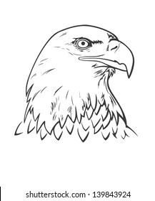
- Identify the type of food which a bird with the above beak feeds on.
________________________________________________________________________________________________________________________________________
- How is a fish and a frog similar in the way they reproduce?
________________________________________________________________________________________________________________________________________
- Name any one kingdom of living things apart from animal kingdom.
________________________________________________________________________________________________________________________________________
- How does a grasshopper differ from a bee in terms of life cycle?
________________________________________________________________________________________________________________________________________
- Suggest any one method used to improve soil fertility.
________________________________________________________________________________________________________________________________________
- How are worker bees important in crop farming?
________________________________________________________________________________________________________________________________________
- Give any one way the body can acquire immunity.
________________________________________________________________________________________________________________________________________
- How does greasing of metal parts prevent them from rusting?
________________________________________________________________________________________________________________________________________
- Which part of the human ear maintains body posture?
________________________________________________________________________________________________________________________________________
- Name the garden tool used for transplanting seedlings.
________________________________________________________________________________________________________________________________________
- How are earthworms useful to soil?
________________________________________________________________________________________________________________________________________
- Why is freezing regarded as a physical change?
________________________________________________________________________________________________________________________________________
- What does a germinating seed use for taking in water and air (oxygen)?
________________________________________________________________________________________________________________________________________
- State any one characteristic of arachnids.
________________________________________________________________________________________________________________________________________
- Suggest any one way in which a school garden is important to a community.
________________________________________________________________________________________________________________________________________
- How is sound produced?
________________________________________________________________________________________________________________________________________
- Why does an empty bottle float on water?
________________________________________________________________________________________________________________________________________
- Write down any one element of Primary Health Care.
________________________________________________________________________________________________________________________________________
- What is the gestation period of a rabbit?
________________________________________________________________________________________________________________________________________
- How are the gills of a mushroom important to it?
________________________________________________________________________________________________________________________________________
- Why does a millipede coil when disturbed?
________________________________________________________________________________________________________________________________________
- State any one example of a water cleaned disease.
________________________________________________________________________________________________________________________________________
- Write down any one property of air.
________________________________________________________________________________________________________________________________________
- Give one disease which has increased the number of extended families in Uganda.
________________________________________________________________________________________________________________________________________
- Where does digestion of food begin?
________________________________________________________________________________________________________________________________________
Study the diagram below and answer questions 30 and 31.
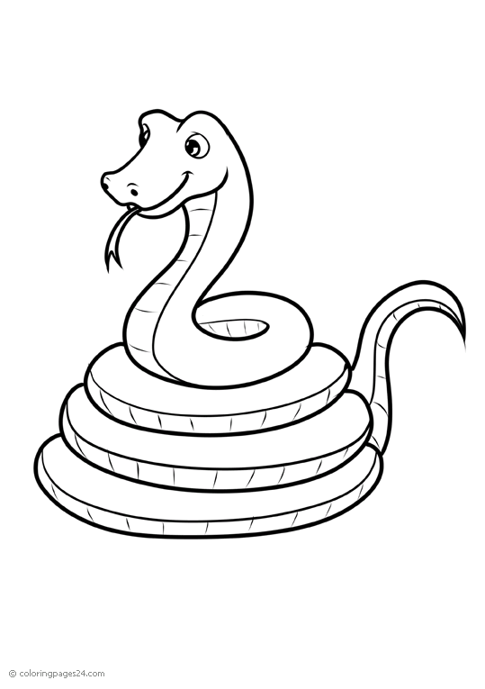
- To which group of vertebrate does the animal above belong?
________________________________________________________________________________________________________________________________________
- How important is the forked tongue to the animal above?
________________________________________________________________________________________________________________________________________
- Which term means water in solid form?
____________________________________________________________________
- What is poultry?
________________________________________________________________________________________________________________________________________
- Name any one breed of rabbits kept in Uganda.
________________________________________________________________________________________________________________________________________
- State any one way of controlling pests.
________________________________________________________________________________________________________________________________________
- Mention any one value of soil to people.
________________________________________________________________________________________________________________________________________
- Why is overgrazing regarded as a dangerous practice in agriculture?
________________________________________________________________________________________________________________________________________
- What causes malaria?
________________________________________________________________________________________________________________________________________
- Why do objects thrown in air fall back on the ground?
________________________________________________________________________________________________________________________________________
- An object has a mass 15gm and a volume 30CC. Calculate its density.

SECTION B
41(a) What are birds of prey?
________________________________________________________________________________________________________________________________________
(b) Write down any two examples of scavenger birds.
(i) _______________________________________________________________
(ii) ______________________________________________________________
(c) Give any one way by which birds are adapted to flying.
_________________________________________________________________
42(a) What is matter?
_________________________________________________________________
_________________________________________________________________
(b)Name the states of matter below according to the arrangement of particles in each.

A B C
A _______________________________________________________________
B _______________________________________________________________
C ________________________________________________________________
43(a) What is dehydration?
_________________________________________________________________
_________________________________________________________________
(b) Give any one cause of dehydration.
_________________________________________________________________
(c) Name one important salt lost when a person has diarrhoea.
_________________________________________________________________
(d) How can dehydration be treated?
_________________________________________________________________
44(a) State two ways living things depend on non-living things.
(i) _______________________________________________________________
(ii) ______________________________________________________________
(b) Give two ways animals depend on plants.
(i) _______________________________________________________________
(ii) ______________________________________________________________
45.(a) What is piggery?
_________________________________________________________________
_________________________________________________________________
(b) State one requirement for starting a piggery unit.
_________________________________________________________________
_________________________________________________________________
(c) What is farrowing in piggery?
_________________________________________________________________
_________________________________________________________________
(d)Mention one sign of heat in sows.
_________________________________________________________________
46 The diagram below is of a digestive system of man. Study it and answer the questions that follow.
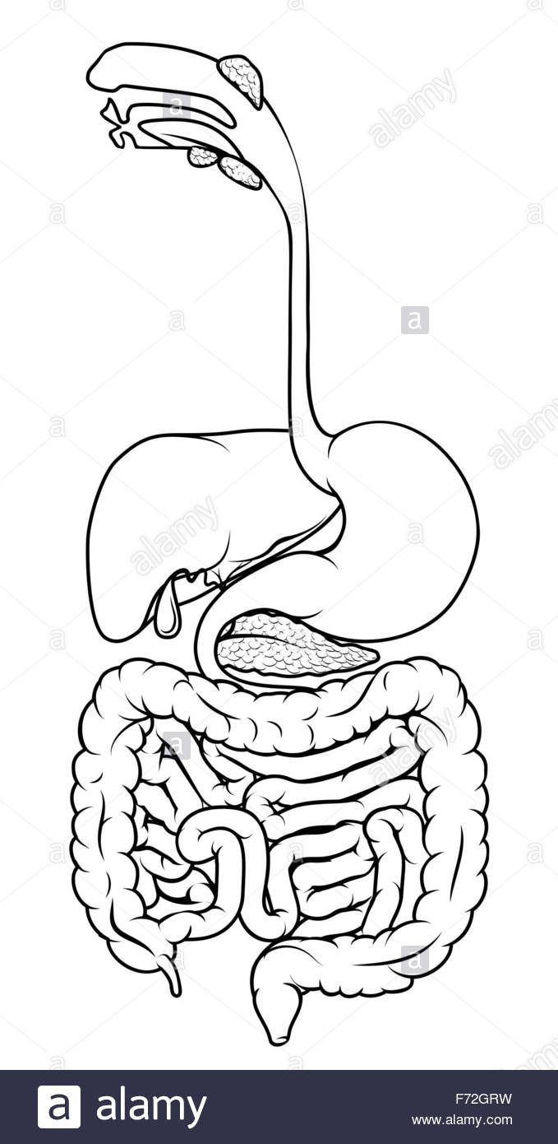
B
F
A
- Name the parts marked;
A _______________________________ B _______________________________
- What important process takes place in part marked F?
_________________________________________________________________
_________________________________________________________________
- Identify one disease which attacks the digestive system.
_________________________________________________________________
_________________________________________________________________
47(a) Write PHC in full.
_________________________________________________________________
_________________________________________________________________
(b) Identify the element of PHC in which each of the following activities is involved:-
(i) Washing the face_________________________________________________
(ii) Sweeping the compound __________________________________________
(c) Why do we boil water for drinking?
_________________________________________________________________
48(a) State the function of the following types of teeth.
- Canines ________________________________________________________
(ii) incisors ________________________________________________________
(b) Mention two ways of caring for our teeth.
(i) _______________________________________________________________
(ii) ______________________________________________________________
49.(a) Identify the vaccines given against the diseases below:-
(i) Polio___________________________________________________________
(ii) Tuberculosis ____________________________________________________
(b)What is the importance of immunization?
_________________________________________________________________
(c) Besides the eight childhood immunisable diseases, name any one other immunisable disease.
_________________________________________________________________
50 Below is a diagram of soil layers. Study it and answer the questions that follow.

A

B

C

(a) What scientific name is given to the arrangement of soil layers shown?
_________________________________________________________________
_________________________________________________________________
(b) Name the layers marked:-
(i) A _____________________________________
(ii) C ____________________________________
(c) Why do you think that soil layer A is the best for plant growth?
_________________________________________________________________
51(a) Suggest any one activity a farmer can do during:-
- dry season.
_________________________________________________________________
_________________________________________________________________
- wet season.
_________________________________________________________________
_________________________________________________________________
(b)How can the following be controlled on a farm:-
(i) soil erosion?
_________________________________________________________________
(ii) weeds in the garden?
_________________________________________________________________
52(a) Give any two sources of sound.
(i) _______________________________________________________________
(ii) ______________________________________________________________
(b) Mention any one use of echo to:-
(i) a bat
_________________________________________________________________
_________________________________________________________________
(ii) a sailor
_________________________________________________________________
_________________________________________________________________
53.(a) Who are vulnerable groups of people?
_________________________________________________________________
(b) Mention two groups of vulnerable.
(i) _______________________________________________________________
(ii) ______________________________________________________________
(c) In which way can the vulnerable be cared for?
_________________________________________________________________
_________________________________________________________________

54(a) What is poultry?
_________________________________________________________________
_________________________________________________________________

(b) Give one type of poultry kept for a special purpose.
_________________________________________________________________
(c) Identify any two causes of vices among poultry.
(i) _______________________________________________________________
(ii) ______________________________________________________________
55. Study the diagram of casuality below and answer the questions that follow.
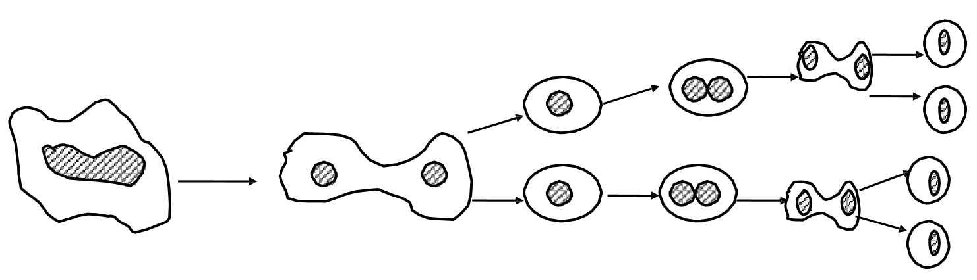
- Name the mean of reproduction shown above.
_________________________________________________________________
_________________________________________________________________
- Which group of living things reproduces by the mean shown above?
_________________________________________________________________
_________________________________________________________________
- State any two common places where we can find the organism named in (b) above.
(i) _______________________________________________________________
(ii) ______________________________________________________________
Good luck
Marking guide for P6 Science BOT II 2024
Section A

- Feeling
- Sunshine dries/withers/wilts the farmer’s crops.
- Solid state
- Breathing/Transpiration
- Meat/ flesh
- Both lay eggs/Both undergo external fertilization.
- Plant kingdom/Bacteria kingdom (prokaryote)/protoctista kingdom/fungi kingdom.
- A grasshopper undergoes incomplete metamorphosis (3 stages) while a bee undergoes complete metamorphosis (4 stages)
- Mulching/crop rotation/application of manure/fertilizers.
- Worker bees pollinate flowers/aid pollination.
- Through immunization or vaccination/breast feeding/after recovery from an illness/Eating a balanced diet.
- Grease cuts off oxygen and water supply to the hoe.
- The semi-circular canal.
- Trowel
- Earthworms aerate the soil.
- Freezing is reversible/no new substance is formed.
- Micropyle
- They have two body parts/four pair of legs/they are wingless.
- Source of food/study purpose/children learn how to dig/source of income.
- By vibration.
- It is less dense than water.
- Immunization/first aid/sanitation/family planning/personal hygiene/food and nutrition/food hygiene.
- 30 days (1 month)
- They store spores/produce spores.
- For protection.
- Conjunctivitis/Diarrhoea/scabies/
impetigo/Trachoma
- Air occupies space/has weight/exerts pressure/can be compressed.
- HIV/Aids
- Mouth
- Reptiles
- For detecting/ sensing enemies.
- Ice
- Poultry refers to all forms of domestic fowls (birds)
- Chinchilla/California/Angora/Earlop/Newzeland white
- Use of a trap/crop rotation/spraying using pesticides/poisoning/use of predators.
- For farming/building/crafts/road construction.
- Overgrazing causes soil erosion.
- Protozoa/plasmodium
- Due to pull of gravity.
- Density = Mass
Volume
₁
= 15gm
30cc
²
Density = ½ gm/cc or 0.5 gm/cm³.

Section B

- –
- These are birds which hunt and kill their prey.
- Vultures/crows/marabou stones.
- They are streamlined/have hollow bones/have wings/have flight feathers/nictating membrane.
- –
- Matter is anything that has mass and volume.
- (i) solid
(ii) Liquid
- Gas

43. -
(a) Condition of the body when it does not have enough water.
(b) Diarrhoea (excess)
Severe vomiting
(c) Sodium/potassium.
(d) give oral rehydration solution/fluids.
44. –
(a) shelter/water for drinking/air for breathing/stones for building, etc.
(b) food/shelter/shade/oxygen/medicine.
45. –
a) act of rearing/keeping pigs.
b) Land/labour/capital/market/management.
c) Act of producing young piglets by a sow.
d) restlessness/it mounts other sows/the valve swells and turns red/white mucus discharge.
46. -
(a) (i) A - Gullet
(ii) G - Appendix
(b) Absorption of food/digestion of food.
(c) Cholera/Typhoid/peptic ulcers/dysentery/Appendictis/Diorrhoea.
47. –
a) Primary Heath Care.
b) (i) Personal Hygiene.
(ii) Sanitation.
c) To kill germs.
48(a) (i) Canines - tearing food.
(ii) Incisors - cutting/biting food
b) brushing the teeth regularly/flossing/tooth picking/regular visits to the dentist/avoid sweets.
49. –
a) (i) polio vaccine/sabin.
(ii) BCG vaccine.
- Boosts the immunity/prevents childhood killer diseases.
- Cholera/meningitis/Ebola/yellow fever/Rabies/Small pox/cervical cancer.
50. -
(a) soil profile.
(b) (i) A- Top soil
(ii) C – parent rocks.
(c) It contains oxygen and nutrients which plants need.
51. –
(a) (i) Harvesting and drying crops.
(ii) Preparing and planting crops/weeding.
b) (i) Crop rotation/mulching/terracing/strip cropping/contour ploughing/ afforestation.
(ii) mulching/slashing/spraying with herbicides/uprooting/etc
52. –
(a) Musical instruments/birds/bell/animals/ man/vehicles.
b) (i) locate food/find their way.
(ii) determines the depth of the sea.
53. –
(a) Groups of people who need special attention.
(b) Pregnant mothers/Breast feeding mothers/Breast fed children/weaning children/sick people/elderly people.
c) feeding them well/bathing them/ medical care/washing for them/give them fluids.
54. –
(a) Poultry refers to all forms of domestic fowls or birds.
b) broilers/layers/dual purpose.
c) - poor feeding.
- over crowding
- boredom
55. –
(a) (i) binary fission
(ii) Bacteria
(iii) Toilets, dead bodies, rubbish pits, air, dirty water

